Component in brief
You will need to know how organisations use digital systems and the wider implications associated with their use.

This component will give you an opportunity to explore how the developments in technology over recent years have enabled modern organisations to communicate and collaborate more effectively than ever before. The component is designed to allow you to explore the digital systems available to organisations and how their features have an impact on the way organisations operate. You will explore how developments in technology have led to more inclusive and flexible working environments, and how regulation and ethical and security concerns influence the way in which organisations operate.

How you will be assessed

This component is assessed through an external assessment that is set and marked by Pearson. It will have questions totalling 60 marks. The test duration is 1 hour 30 minutes.

When you will be assessed

Assessment is available twice a year in February and May. You will sit the component in either Y10 or Y11.

How to Revise


The revision guide is available to purchase from the school shop and gives lots of revision notes and practice questions to help you prepare for the assessment. You also have the PowerPoints you used in lessons and the revision maps you produced at the end of each section.

Command Words

Each question will have a command word which helps you to answer the question with the correct detail, examples or content. It is really important you understand what you need to do for each of the command words. The table below will help you.
Command Word | How to answer
Give/State/Name | - Identify the command word  - Read the question – think about in your own words what is the question?  - Highlight/underline keywords  - Recall – just write a word or two – write a statement of fact  - Check you haven’t repeated yourself if asked for more than one answer
Identify | - Identify the command word  - Read the question – think about in your own words what is the question?  - Recall – just write a word or two – write a statement of fact using the scenario or question  - Check you haven’t repeated yourself if asked for more than one answer
Explain | Most questions in the exam use this command word  - Identify the command word  - Read the question – think about in your own words what is the question?  - Highlight/underline keywords  - Write an answer  - Then expand with a linked justification using words such as: so that , therefore, because, for example
Annotate | - Identify the command word  - Read the question – think about in your own words what is the question?  - Highlight/underline keywords  - Label (identify) usually using an arrow  - Describe what you have labelled using the question to tell you what to describe
Draw | - Identify the command word  - Read the question – think about in your own words what is the question?  - Highlight/underline keywords  - Produce an annotated process either in the form of an information flow or data flow diagram
Describe | - Identify the command word  - Read the question – think about in your own words what is the question?  - Highlight/underline keywords  - Start the answer with the name of the person or organisation in the scenario  - Give a clear, objective account in your own words, showing recall, and application, of relevant features and information.
Discuss | Marked using level-based mark scheme  - Identify the command word  - Read the question – think about in your own words what is the question?  - Highlight/underline keywords  - Start the answer with the name of the person or organisation in the scenario.  - Make as many points as you can linked to the question  - Explain each point  - Check you have displayed a well-developed and logical discussion which clearly considers a range of different points and how they interrelate with content from across the specification.
Evaluate | Marked using level-based mark scheme  - Identify the command word  - Read the question – think about in your own words what is the question?  - Highlight/underline keywords  - Plan this question before you start - must have a balanced argument – risks/benefits, positive/negatives, strengths/weaknesses, alternatives  - Start your answer with the name of the company or person i.e. Sarah could ..  - Explain the positives, linked to the scenario and question  - Explain the negatives, linked to the scenario and question  - Finish with a supported conclusion with your opinion, the reason you think it and the answer to the question
Assess | Marked using level-based mark scheme  - Identify the command word  - Read the question – think about in your own words what is the question?  - Highlight/underline keywords  - Plan this question before you start - must have lots of factors or events to discuss and decide which is the most important  - Start your answer with the name of the company or person i.e. Sarah could ..  - Explain each of the factors, linked to the scenario and question  - Finish with a supported conclusion with your opinion on which is the most important and the reason you think it  - Check you have answered the question

A - Modern technologies

What the spec says you need to know

You need to know about how current and modern technologies are used by and have an impact on organisations and their stakeholders. You need to know the ways in which organisations and associated individuals use modern technologies to exchange information, communicate, and complete work-related tasks. You must be able to apply their knowledge to a range of vocational contexts.

A1 Modern technologies
Understand how and why modern technologies are used by organisations and stakeholders to access and manipulate data, and to provide access to systems and tools in order to complete tasks.

You should understand the implications of these tools and technologies for organisations and stakeholders.
• Communication technologies:

o setting up ad hoc networks (open Wi-Fi, tethering/personal hotspot)
o security issues with open networks
o performance issues with ad hoc networks
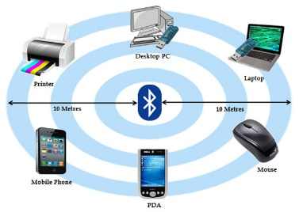
o issues affecting network availability (rural vs city locations, developed vs developing countries, available infrastructure, mobile network coverage, blackspots).
• Features and uses of cloud storage:
o setting and sharing of access rights
o synchronisation of cloud and individual devices
o availability (24/7)
o scalability (getting more by renting/freeing to save money).
• Features and uses of cloud computing:
o online applications
o consistency of version between users (features, file types)
o single shared instance of a file
o collaboration tools/features.
• How the selection of platforms and services impacts on the use of cloud technologies:

o number and complexity of features
o paid for versus free
o interface design (layout, accessibility, mobile vs desktop)
o available devices.
• How cloud and ‘traditional’ systems are used together:
o device synchronisation
o online/offline working
o notifications.
• Implications for organisations when choosing cloud technologies:
o consideration of disaster recovery policies (service provider’s, organisation’s)
o security of data (location, service provider’s security procedures and features)
o compatibility
o maintenance (software updates, downtime, staff expertise)
o getting a service/storage up and running quickly
o performance considerations (responsiveness to user, complexity of task, available devices and communication technologies)



A2 Impact of modern technologies
You should understand how modern technologies impact on the way organisations perform tasks. You should understand how technologies are used to manage teams, to enable stakeholders to access tools and services, and to communicate effectively. You should understand the positive and negative impact that the use of modern technologies has on organisations and stakeholders.

• Changes to modern teams facilitated by modern technologies:
o world teams (not bound by geographical restrictions, diversity)
o multicultural
o inclusivity (facilitation of member’s needs)
o 24/7/365 (no set work hours, team members in different time zones)
o flexibility (remote working vs office based, permanent vs casual staff).
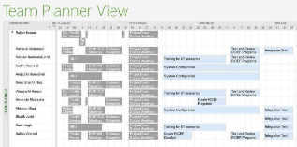
• How modern technologies can be used to manage modern teams:
o collaboration tools
o communication tools
o scheduling and planning tools.
• How organisations use modern technologies to communicate with stakeholders:
o communication platforms (website, social media, email, voice communication)
o selection of appropriate communication channels (private/direct message, public status update) for sharing information, data and media.
• How modern technologies aid inclusivity and accessibility:
o interface design (layout, font and colour selection)
o accessibility features (screen reader support, alt text, adjustable typeface/font size, text to speech/’listen to this page’)
o flexibility of work hours and locations.
• Positive and negative impacts of modern technologies on organisations in terms of:
o required infrastructure (communication technologies, devices, local and web-based platforms)
o demand on infrastructure of chosen tools/platforms
o availability of infrastructure
o 24/7 access
o security of distributed/disbursed data
o collaboration
o inclusivity (age, health, additional needs, multicultural)
o accessibility (meeting legal obligations, provision requirements)
o remote working.
• Positive and negative impacts of modern technologies on individuals:
o flexibility (home/remote working)
o working styles (choice of time, device, location)
o impact on individual mental wellbeing (depression, loneliness, self-confidence, separation from stressful environment, feel in control of own schedule, schedule adjusted to meet needs of family, less time commuting).

Example Exam Question

Sid works as a scientist for C21 Pharmaceuticals, a company researching and manufacturing new drugs for medical use. He commutes to work every weekday by train.
While he is on the train, he works on his laptop. He can connect to the office network by tethering his smartphone to his laptop to create an ad hoc network.
- Describe how Sid can set up an ad hoc network instead of using the train’s free Wi-Fi facility. [3 marks]
- Describe one factor which may cause Sid’s laptop to drop the connection to the office network. [2 marks]

B - Cyber Security

What the spec says you need to know

You must understand how the increased reliance of organisations on digital systems to hold data and perform vital functions presents a range of challenges and dangers. They should understand the nature of threats to digital systems and ways that they can be mitigated through organisation policy, procedures and the actions of individuals. They should be able to apply knowledge of cyber security to a range of vocational contexts.

B1 Threats to data
You should understand why systems are attacked, the nature of attacks and how they occur, and the potential impact of breaches in security on the organisation and stakeholders.
• Why systems are attacked:
o fun/challenge
o industrial espionage
o financial gain
o personal attack
o disruption
o data/information theft.

• External threats (threats outside the organisation) to digital systems and data security:
o unauthorised access/hacking (black hat)
o malware (virus, worms, botnet, rootkit, Trojan, ransomware, spyware)

o denial of service attacks
o phishing (emails, texts, phone calls)
o pharming
o social engineering
o shoulder surfing
o ‘man-in-the-middle’ attacks.
• Internal threats (threats within the organisation) to digital systems and data security:
o unintentional disclosure of data
o intentional stealing or leaking of information
o users overriding security controls
o use of portable storage devices
o downloads from internet
o visiting untrustworthy websites.
• Impact of security breach:
o data loss
o damage to public image
o financial loss
o reduction in productivity
o downtime
o legal action.

B2 Prevention and management of threats to data
You should understand how different measures can be implemented to protect digital systems. You should understand the purpose of different systems and how their features and functionality protect digital systems. You should understand how one or more systems or procedures can be used to reduce the nature and/or impact of threats.

• User access restriction:
o physical security measures (locks)
o passwords
o using correct settings and levels of permitted access
o biometrics
o two-factor authentication (who you are, what you know, what you have).
• Data level protection:
o firewall (hardware and software)
o software/interface design (obscuring data entry, autocomplete, ‘stay logged in’)

o anti-virus software
o device hardening
o procedures for backing up and recovering data
o encryption of stored data (individual files, drive)
o encryption of transmitted data.

• Finding weaknesses and improving system security:
o ethical hacking (white hat, grey hat)
o penetration testing
o analyse system data/behaviours to identify potential risks.

B3 Policy
You should understand the need for and nature of security policies in organisations. You should understand the content that constitutes a good security policy and how it is communicated to individuals in an organisation. To ensure that potential threats and the impact of security breaches are minimised, you should understand how procedures in security policies are implemented in organisations.

• Defining responsibilities:
o who is responsible for what
o how to report concerns
o reporting to staff/employees.
• Defining security parameters:
o password policy
o acceptable software/installation/usage policy
o parameters for device hardening.
• Disaster recovery policy:
o who is responsible for what
o dos and don’ts for staff
o defining the backup process (what is backed up, scheduling, media)
o timeline for data recovery
o location alternative provision (hardware, software, personnel).
• Actions to take after an attack:
o investigate (establish severity and nature)
o respond (inform/update stakeholders and appropriate authorities)
o manage (containment, procedures appropriate to nature and severity)
o recover (implement disaster recovery plan, remedial action)
o analyse (update policy and procedures).

Example Exam Question

Anderson Insurance Company sells vehicle, home and other insurance policies. All employees use personal computers in the office.
The management has created an Acceptable Use policy which all employees must adhere to.
- Identify two topics which would typically be found in an Acceptable Use policy. [2 marks]
- Explain two reasons why an Acceptable Use policy is necessary for an organisation. [4 marks]

C - The wider implications of digital systems

What the spec says you need to know

You should understand the wider implications of digital systems and their use. You should
understand how legislation covering data protection, computer crimes and intellectual property has an impact on the way that organisations and individuals use digital systems and data. You should understand the procedures that organisations must follow in order to conform to legal requirements and professional guidelines.

C1 Responsible use
You should consider the responsible use of digital systems, including how systems and services
share and exchange data as well as the environmental considerations of increased use.

• Shared data (location-based data, transactional data, cookies, data exchange between services):

o benefits of using shared data
o drawbacks of using shared data
o responsible use (legal considerations, privacy, ethical use).
• Environmental:
o impact of manufacturing, use, and disposal of IT systems (energy, waste, rare materials)
o considerations when upgrading or replacing digital systems
o usage and settings policies (auto power off, power-saving settings, hard copy vs electronic distribution).

C2 Legal and ethical

You should understand the scope and purpose of legislation that governs the use of digital systems and data, and how it has an impact on the ways in which organisations use and implement digital systems. You should understand the wider ethical considerations of use of technologies, data and information, and organisations’ responsibilities to ensure that they behave in an ethical manner.


• Importance of providing equal access to services and information:
o benefits to organisations, individuals and society
o legal requirements
o professional guidelines/accepted standards.
• Net neutrality and how it impacts on organisations.
• The purpose and use of acceptable use policies:
o scope – who the document applies to
o assets – the equipment, documents, and knowledge covered by the policy
o acceptable – behaviours that are expected/required by an organisation
o unacceptable – behaviours that are not allowed by an organisation
o monitoring – description of how behaviour is monitored by an organisation
o sanctions – defining the processes and potential sanctions if unacceptable behaviour occurs
o agreement – acknowledge (sign, click) that an individual agrees to abide by the policy.

• Blurring of social and business boundaries:
o use of social media for business purposes
o impact of personal use of digital systems (social media, web) on professional life.
• Data protection principles:
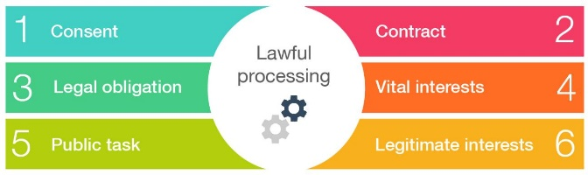
o lawful processing
o collected only for specific purpose
o only needed information is collected
o should be accurate
o kept only as long as is necessary
o data subject rights
o protected
o not transferred to countries with less protection.
• Data and the use of the internet:
o the right to be forgotten
o appropriate and legal use of cookies and other transactional data.
• Dealing with intellectual property:
o the importance of intellectual property in organisations
o methods of identifying/protecting intellectual property (trademarks, patents copyright)
o legal and ethical use of intellectual property (permissions, licensing, attribution).

• The criminal use of computer systems:
o unauthorised access
o unauthorised modification of materials
o creation of malware
o intentional spreading of malware.

Example Exam Question

The company is planning to upgrade all of its 300 PCs to a newer model with more memory and a faster processor. The management is concerned about the environmental impact of the production of new computers and the improper disposal of the old ones.
- Discuss how the manufacture of new computers and disposal of old ones can contribute to environmental damage. [6 marks]

Some of the new drugs manufactured by C21 Pharmaceuticals take years to develop and test.
They need to protect their intellectual property.
- Explain one method the company can use to protect their intellectual property. [2 marks]

D - Planning and communication in digital systems

What the spec says you need to know

You should understand how individuals in the digital sector plan solutions and communicate meaning and intention. They should understand how different forms of written and diagrammatical communication can be used to express understanding and demonstrate the flow of data and information.

D1 Forms of notation
You should be able to interpret and use standard conventions to combine diagrammatical and written information to express an understanding of concepts.
• Understand how organisations use different forms of notation to explain systems, data and information:
o data flow diagrams
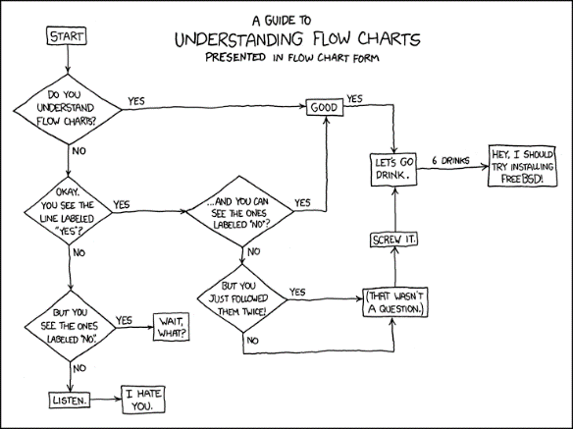
o flowcharts
o system diagrams
o tables
o written information.

• Be able to interpret information presented using different forms of notation in a range of contexts.
• Be able to present knowledge and understanding using different forms of notations:
o data flow diagrams
o information flow diagrams
o flowcharts

Example Exam Question

Premiums on car insurance from Anderson insurance are calculated based on the value of the vehicle, and the age and driving record of the driver.
Drivers under 25 are given a 25% discount on their premium if they have a “black box” installed in their car, which records their driving performance. Drivers aged 25 and over do not receive any “black box” discount.
The company has a computer program for calculating insurance premiums.
- It calculates the basic premium for the car he wants to insure
- If the driver is under 25 years old, the premium is doubled
- If the driver is under 25, and has a black box fitted, there is a 25% reduction in the premium.

- Draw the missing segment of the flowchart which shows how the premium is calculated. [4 marks]
